Lecture 08 — Interaction Diagrams (Continued)
Prepared by Sandaruwani Pathirage

Sequence Diagram
A sequence diagram is a UML interaction diagram that shows how actors, objects, or system components exchange messages over time to complete a scenario.

It arranges participants horizontally and messages vertically, making the order of requests, responses, conditions, and loops easier to understand.
Sequence diagrams are widely used in software development to visualize system behavior and help developers design, analyze, and understand complex interactions.

When to Use Sequence Diagrams?
- Model a specific use case or scenario: Use sequence diagrams to illustrate how a system behaves during a single use case, showing the step-by-step flow of messages between objects.
- Design or refine system architecture: Visualize how components such as the UI, business logic, and database interact, helping architects plan or improve system structure.
- Clarify complex processes: Break down complicated workflows or logic into clear, time-ordered interactions, making it easier to understand and communicate system behavior.
- Validate logic before implementation: Confirm that all necessary interactions and message flows are defined correctly before coding begins, reducing design errors.
- Explain system behavior to stakeholders: Use sequence diagrams to present technical interactions in a way that both developers and non-technical team members can understand.
- Design or analyze integrations and APIs: Map out how services or systems exchange requests and responses to ensure smooth communication in distributed or microservice environments.

UML Sequence Diagram Symbols and Notation
Objects and Lifelines
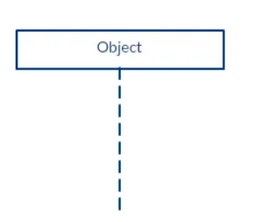

- A sequence diagram contains several lifeline notations arranged horizontally across the top.

- Lifeline notations should not overlap each other.

- Each lifeline represents an object or part of the system that participates in interactions.

- Each object has a lifeline, shown as a dashed vertical line starting from the bottom center of its object box.

- The lifeline indicates the object's existence or lifespan during the sequence of events.

A lifeline notation with an actor element symbol is used when the particular sequence diagram is owned by a use case.

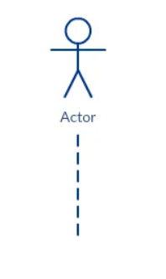
A lifeline with an entity element represents system data. For example, in a customer service application, the Customer entity would manage all data related to a customer.
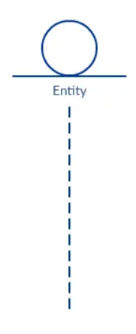
A lifeline with a boundary element indicates a system boundary/ software element in a system; for example, user interface screens, database gateways or menus that users interact with, are boundaries.

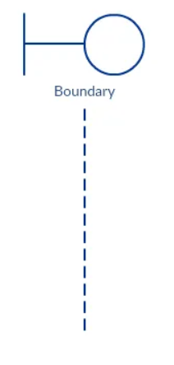
And a lifeline with a control element indicates a controlling entity or manager. It organizes and schedules the interactions between the boundaries and entities and serves as the mediator between them.
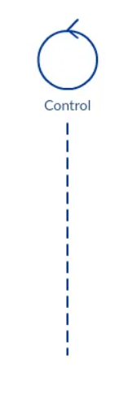
Activation Bars
The activation bar is the box placed on the lifeline. It is used to indicate that an object is active (or instantiated) during an interaction between two objects. The length of the rectangle indicates the duration of the objects staying active.

- An interaction occurs when one object sends a message to another object.

- Message Caller: The object that sends the message.

- Message Receiver: The object that receives the message.

- Activation bar: A thin rectangle on a lifeline that indicates when an object is active or executing an operation.

- The Message Caller is active when it sends the message.

- The Message Receiver becomes active when it receives the message and begins processing it.

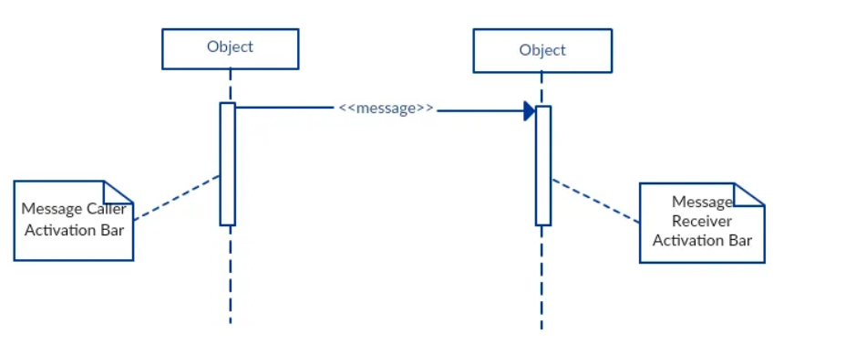

Message Arrows
- A message arrow represents a message sent from one object to another in a sequence diagram.
- Messages can flow in different directions:
  - Left to right.
  - Right to left.
  - Back to the same object (self-message).
- Different arrowheads represent different types of messages.
- A message arrow includes a message signature, which describes the message being sent.

Message Signature Format:
attribute = message_name(arguments): return_type

Synchronous Message
A synchronous message is used when the sender waits for the receiver to process the message and return before carrying on with another message.
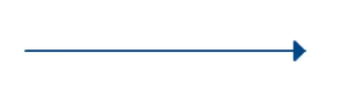
Asynchronous Message
An asynchronous message is used when the message caller does not wait for the receiver to process the message and return before sending other messages to other objects within the system.
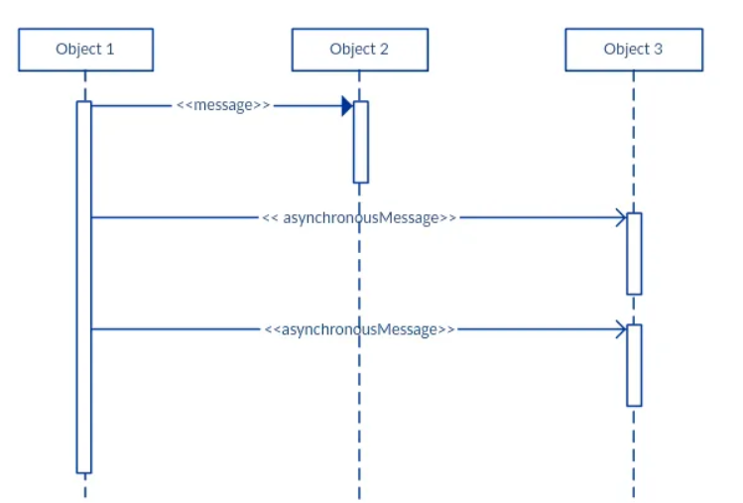
Return Message
A return message is used to indicate that the message receiver is done processing the message and is returning control over to the message caller.

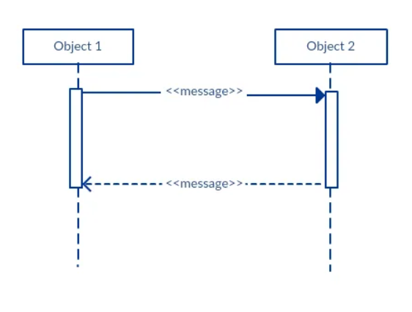
Participant Creation Message
Objects do not necessarily live for the entire duration of the sequence of events. Objects or participants can be created according to the message that is being sent.
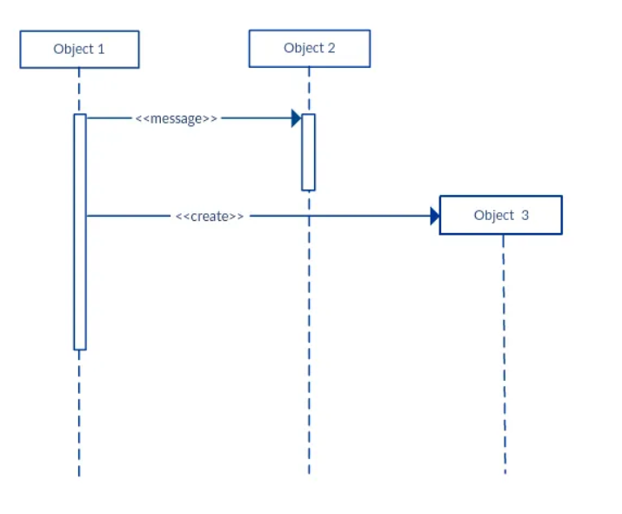
Participant Destruction Message
Likewise, participants when no longer needed can also be deleted from a sequence diagram. This is done by adding an ‘X’ at the end of the lifeline of the said participant.

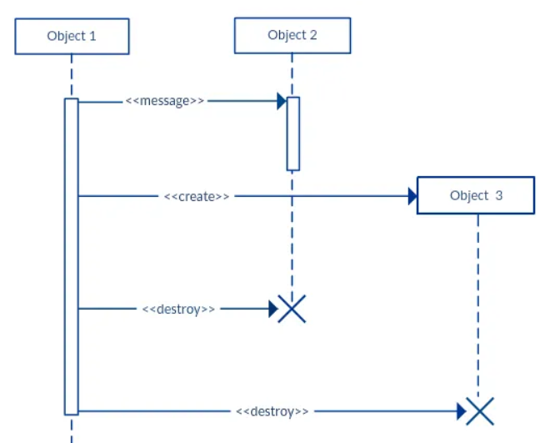

Reflexive Message
When an object sends a message to itself, it is called a reflexive message.

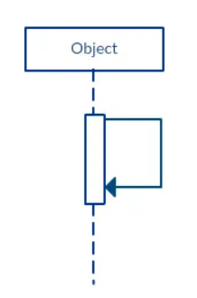
Comment
UML diagrams generally permit the annotation of comments in all UML diagram types. The comment object is a rectangle with a folded-over corner as shown below. The comment can be linked to the related object with a dashed line.
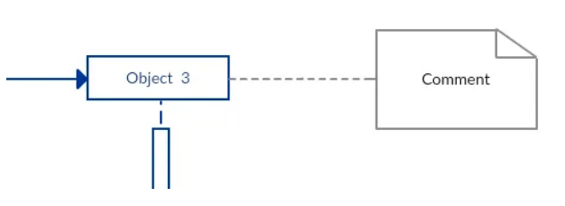

How to Draw a Sequence Diagram
The message flow of the sequence diagram is based on the narrative of the particular use case.
Before you start drawing the sequence diagram or decide what interactions should be included, you need to draw the use case diagram and ready a comprehensive description of what the particular use case does.
Step 1: Identify the Use Case
Start by defining the specific use case scenario you want to model.
Step 2: Identify the Objects and Actors
Before drawing the sequence diagram, it’s necessary to identify the objects or actors that would be involved in creating a new user account. These would be;
- Librarian
- Online Library Management system
- User credentials database
- Email system
Step 3: Describe the Use Case in Detail
Once you identify the objects, it is then important to write a detailed description of what the use case does. From this description, you can easily figure out the interactions (that should go in the sequence diagram) that would occur between the objects above, once the use case is executed.
Step 4: Identify Sequence of Interactions
- The librarian requests the system to create a new online library account.
- The librarian then selects the library user account type.
- The librarian enters the user’s details.
- The user’s details are checked using the user Credentials Database.
- The new library user account is created.
- A summary of the new account’s details are then emailed to the user.

Step 5: Arrange Actors and Lifelines
Step 6: Add Messages and Interaction Details
Step 7: Review and Refine Diagram

UML Sequence Diagram Best Practices
- Draw smaller sequence diagrams
- Avoid unnecessary or repetitive diagrams
- Use clear and consistent naming conventions
- Maintain logical ordering and alignment
- Limit the number of objects per diagram
- Highlight alternative or conditional flows with fragments

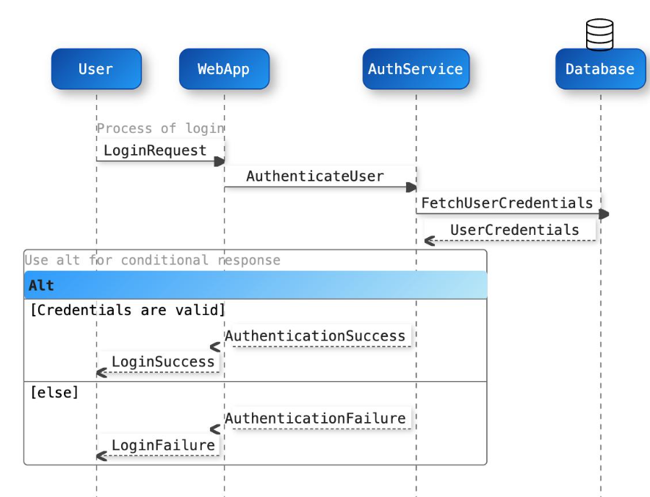
Activities
- A user enters their username and password into a login screen. The Login Screen sends a validateCredentials() message to the Authentication System. The Authentication System checks the credentials and returns the login result to the Login Screen. Draw a UML sequence diagram using only the following two objects:
- LoginScreen
- AuthenticationSystem

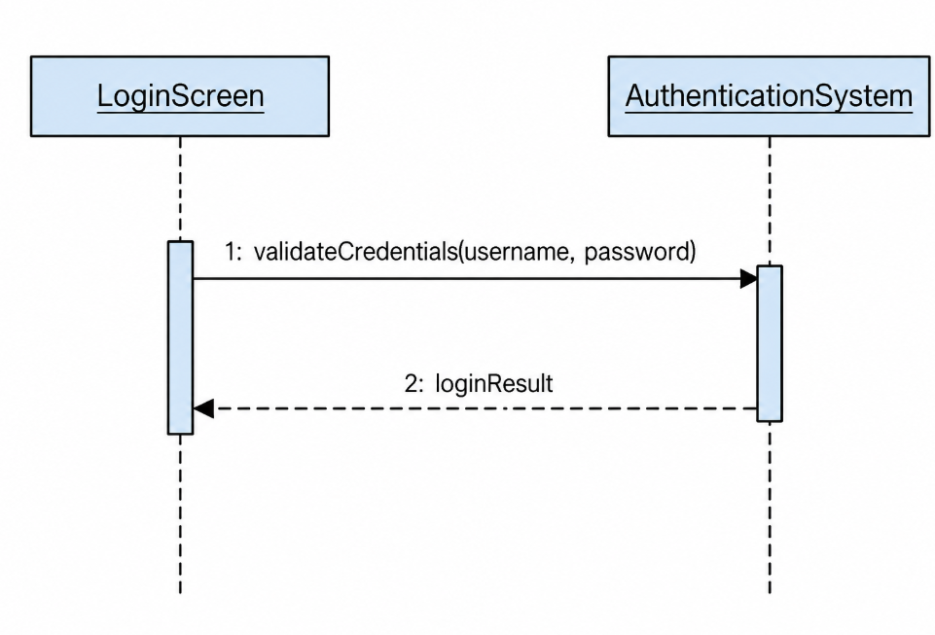
2. When a customer places an order, the FoodOrderingSystem sends the order confirmation details to the NotificationService. While the notification service is processing the confirmation, the food ordering system updates the order status displayed to the customer. The notification service completes sending the confirmation afterward. Draw a UML sequence diagram using the following two objects:
- FoodOrderingSystem
- NotificationService
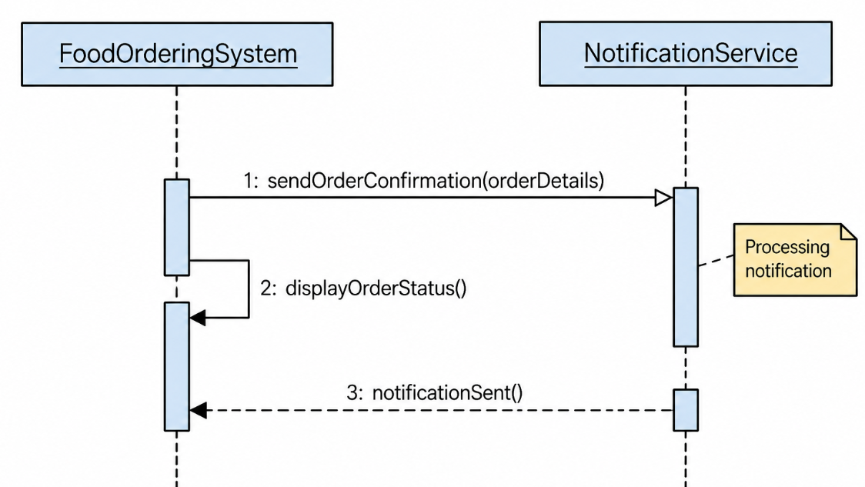

- A student logs into the University Examination System and requests to view their examination results. The system retrieves the results and displays them to the student. Draw a UML sequence diagram for this scenario using the following participants:
Student — Actor
ExaminationSystem — Object

Show the messages exchanged between the student and the examination system, including the request to view results and the system's response.

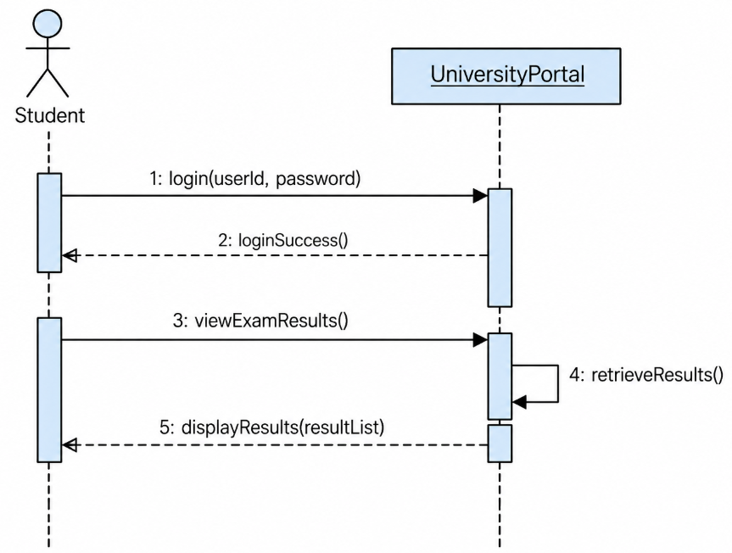

- A student requests to update their phone number through the University Portal. The portal sends the updated phone number to the Student entity to save the new information. The entity then confirms that the update was completed successfully. Draw a UML sequence diagram using the following two participants:
UniversityPortal — Boundary object
Student — Entity object
Show the messages exchanged to update the student's phone number. Use the appropriate UML lifeline notation for the entity object.

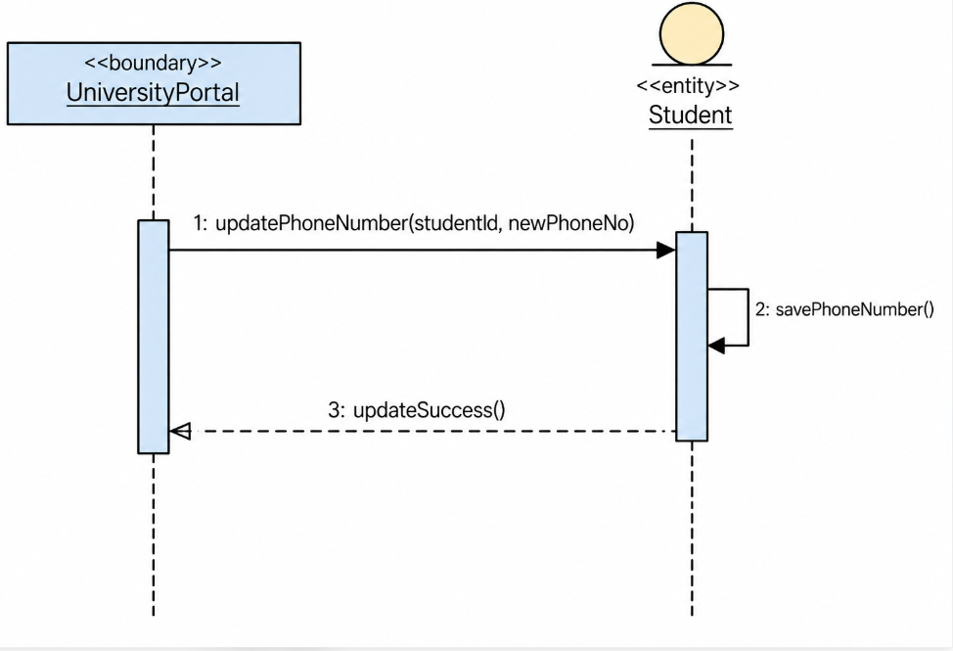

- A librarian enters a book title through the Library Management System interface. The interface sends a request to search for the book to the Library Catalog and displays the search results returned by the catalog. Draw a UML sequence diagram using the following two participants:

LibraryInterface — Boundary object
LibraryCatalog — System object
Show the message sent to search for a book and the return message containing the search results. Use the appropriate UML boundary lifeline notation for LibraryInterface.

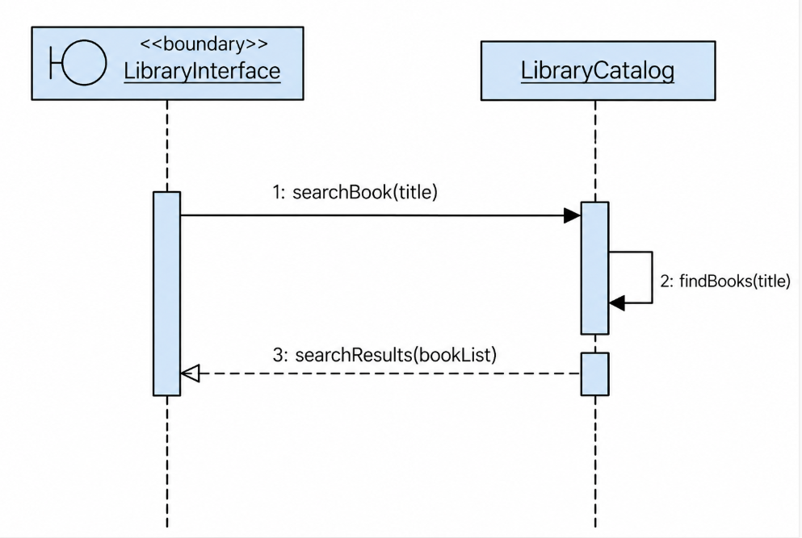

6.A customer requests to withdraw money using an ATM. The ATMInterface sends the withdrawal request to the WithdrawalController. The controller checks the customer's account balance with the BankAccount entity. If sufficient funds are available, the controller instructs the ATM interface to dispense the cash.
Draw a UML sequence diagram using the following participants:
- ATMInterface — Boundary object
- WithdrawalController — Control object
- BankAccount — Entity object
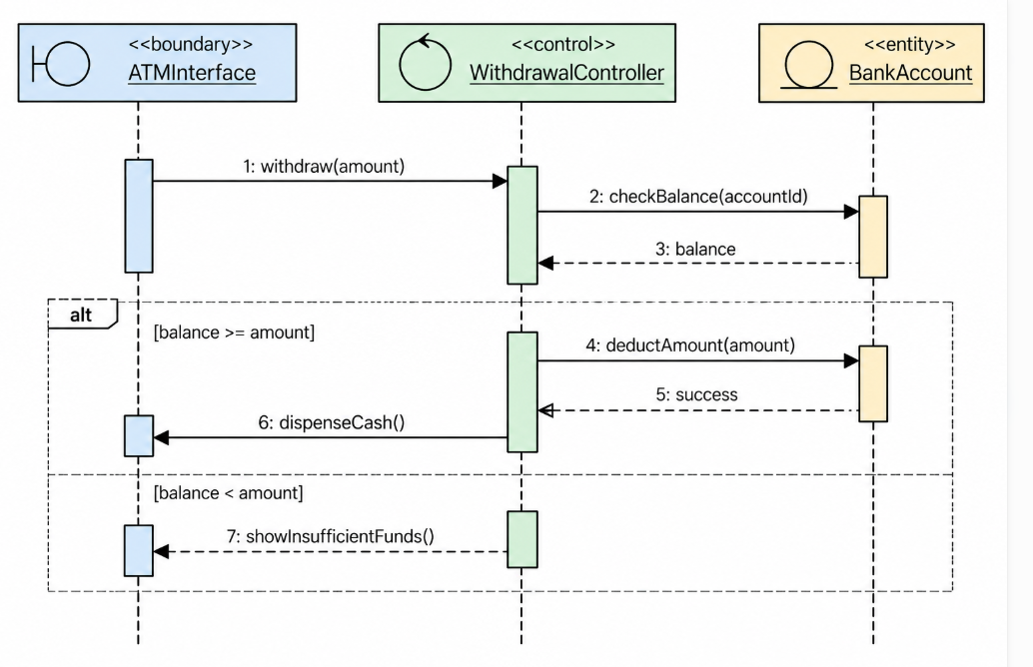
In the ATM sequence diagram, WithdrawalController is the control object. It manages the cash withdrawal process and coordinates communication between the ATM interface and the bank account.
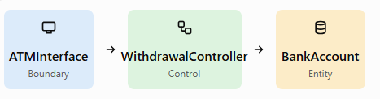

- ATMInterface: Receives the withdrawal amount and displays messages to the customer.
- WithdrawalController: Coordinates the withdrawal steps and decides what to do based on the account balance.
- BankAccount: Represents the customer's account information and balance.

